**Casual Jobs Database v.1**

Client Acceptance & Feedback Form



**Database Design**

To:

Clement Sudhakar Swarnappa  
*Senior Academic Staff Member*

School of Information Technology  
DDI: +64 4 830 3130  
Email: clement.sudhakar@weltec.ac.nz  
URL: www.weltec.ac.nz  
Post : Private Bag 39803, Lower Hutt 5045  
Wellington, New Zealand

Project Team:

Supun Chandra Malimage – Project Manager

Kalaivani Ilango – Team Member

Ruban Ravi Sebastian – Team Member

Table of Contents

Casual jobs database v.1 **Error! Bookmark not defined.**

**Client Acceptance & Feedback Form** 3

Task description: 3

Use case diagram: 3

Class diagram: 5

Activity diagram: 6

Entity Relationship Diagram: 7

Overall Client feedback: 8

Action Plan on this Milestone: 8

Next steps: 8

# **Client Acceptance & Feedback Form**

|  |  |
| --- | --- |
| Milestone - Database design approval | |
| Project Name: Casual Jobs Database V.1 | Client Name: Clement Sudhakar Swarnappa |
| Project Start date: July 6th, 2020 | Project End date: October 9th, 2020 |
| Milestone: Database design approval | Finished date: September 10th, 2020 |
| **Introduction of Milestone:**   * Database design * Data modelling * Use case, Class, Activity and ERD diagram | |

## Task description:

Based on the Rapid Application Development methodology, and the database design requirement, we have created the below attached Use case, Class, Activity and ERD diagram.

## Use case diagram:

Use case diagram represents the actor’s behaviour of the system. Figure 1 shows the high-level requirement of the system and explains the relationship between actors and the different use cases in which the whole system involved. The role of the actors in Casual Jobs Database V.1 is to interact with the system. List of actors in Casual Jobs Database V.1 are as follows:

* AC01 Employer
* AC02 Job Seeker
* AC03 Admin

## Class diagram:

Class diagram represents the structure of the system by showing the system’s classes, their attributes, operations (or methods), and the relationship among objects.

The classes in a class diagram represent both the main elements, interactions in the application, and the classes to be programmed and the multiplicity represents the functions of the classes.

## Activity diagram:

Casual Jobs Database activity diagram explains about the series of actions performed by the employer and the job seeker. It represents the flow from one activity to another activity. Firstly, the employer register into the job portal. Once registration is completed, the employer logins into the portal for accessing the dashboard. Then the employer can edit and post the jobs. On the other hand, Job Seeker also registers into the portal. After registration, the Job Seeker logins into the portal for accessing the dashboard. And then, Job Seeker can add profile and edit it. As the employer and job seeker profile matches, the system sends the matched job seeker profile to the employer, the employer checks and select the candidate. And then the job seeker receives the notification for accepting the application.

## Entity Relationship Diagram:

ERD diagram helps to understand the tables and its relations in the database.

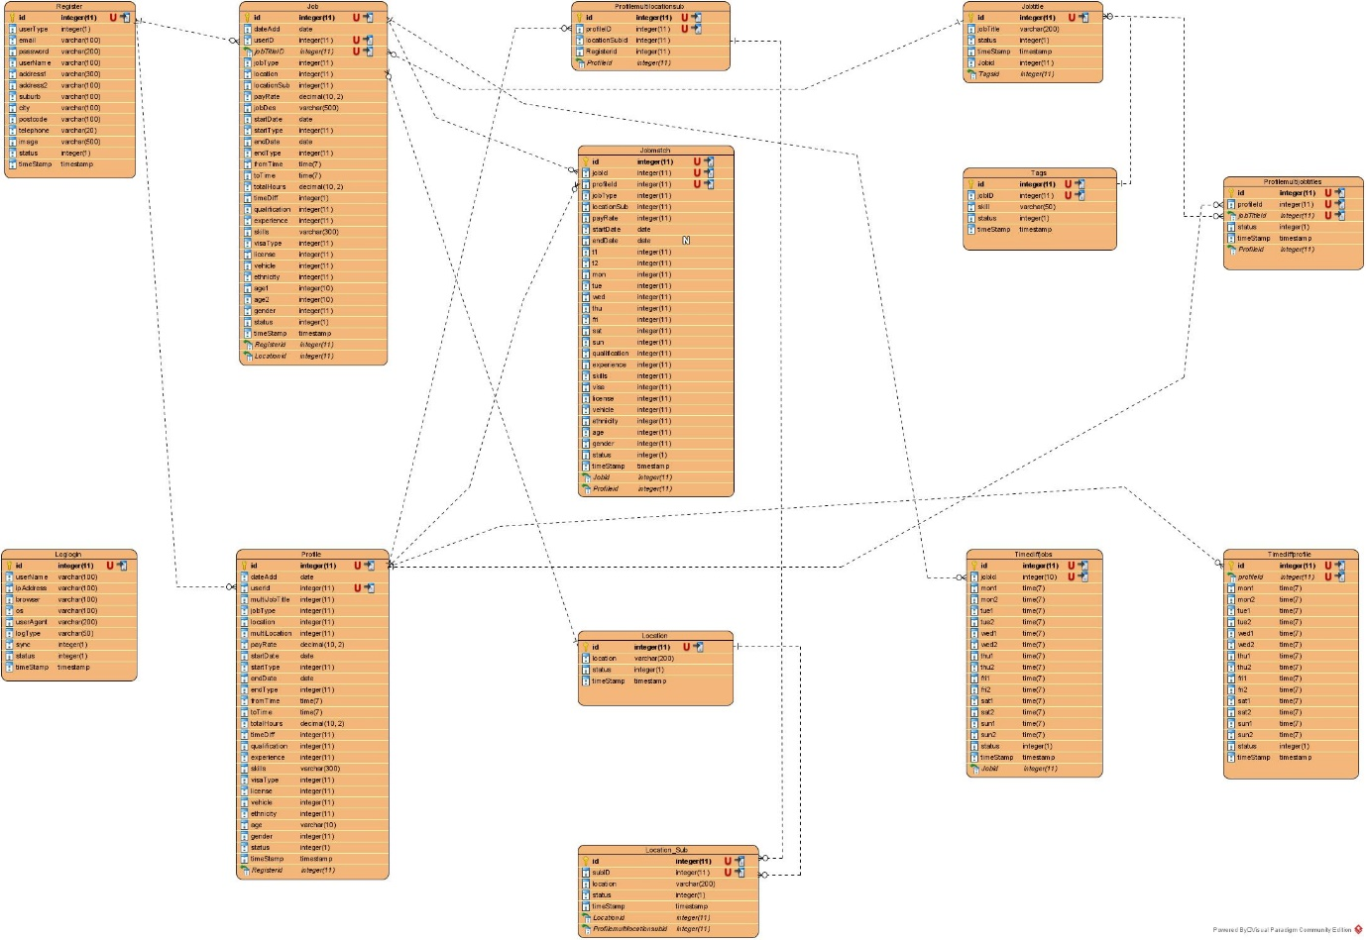

## Overall Client feedback:

## Action Plan on this Milestone:

## Next steps:

**Milestone: Back-end development**

In this milestone, we have planned to do the Back-end development with Employer panel, Job seeker panel and complete the Back end and process modelling.

|  |
| --- |
| **Client Name:** _____________________________________________________________________  **Signature:** _____________________________________________________________________  **Date:** _____________________________________________________________________ |